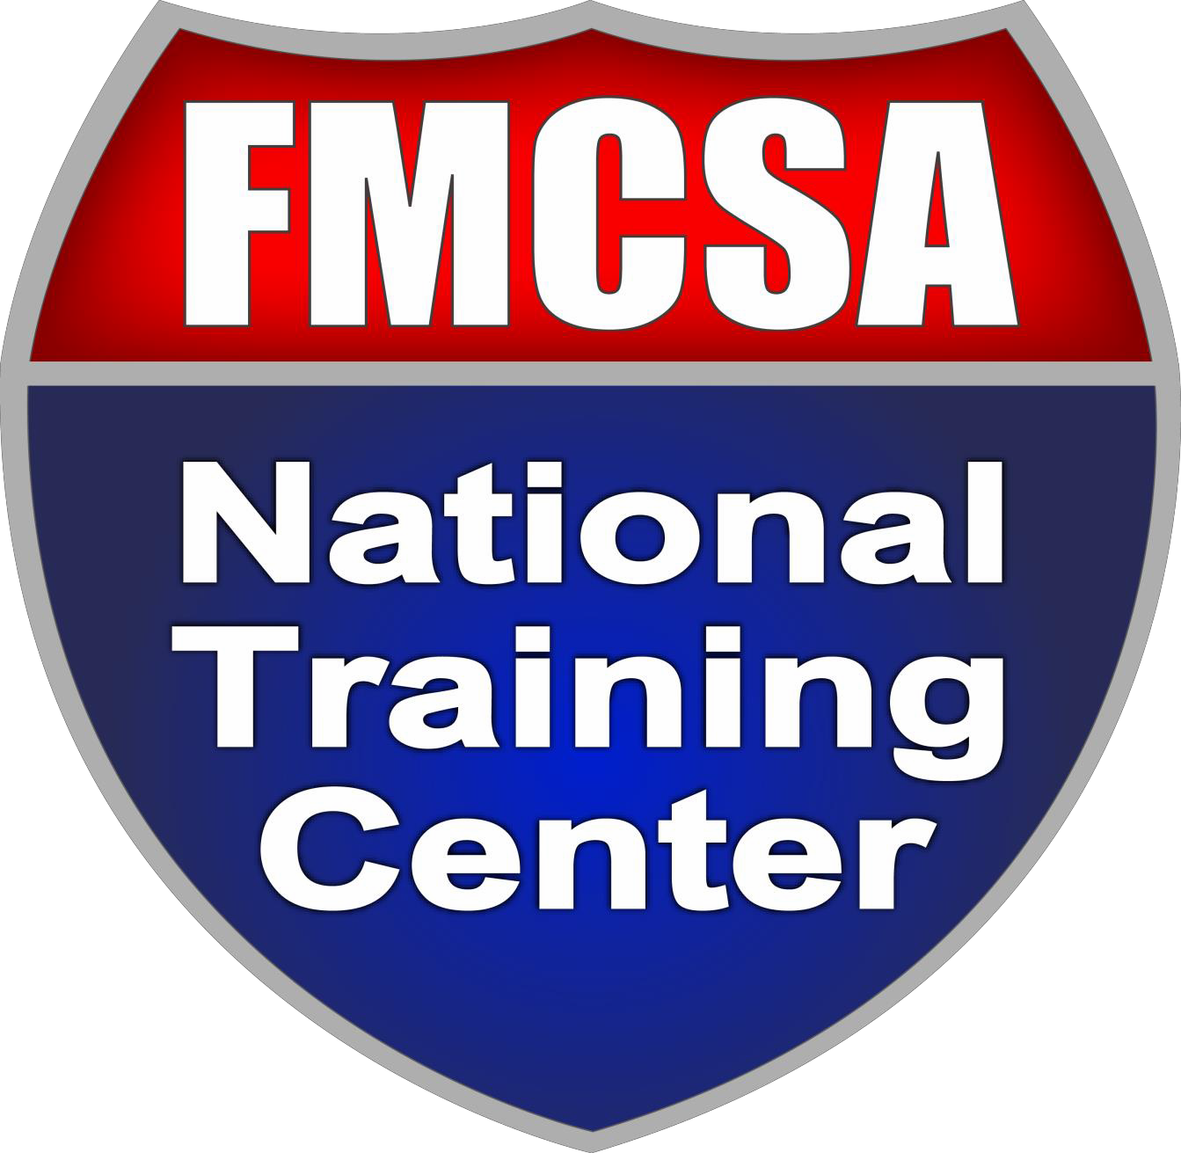

Host Packet

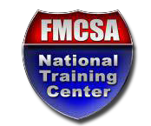
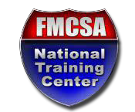
FEDERAL MOTOR CARRIER SAFETY ADMINISTRATION NATIONAL TRAINING CENTER

COURSE INFORMATION
Course Name:
Host Organization:
Course Location:
(City &State)
Course Start Date:
Course End Date:
Instructor Name #1:
Instructor Name #2:
(if applicable)
Instructor Name #3:
(if applicable)
STUDENT COUNTS
State Government Students:
Federal Government Students:
Other Students:
TOTAL:

Once the course and exam have concluded, please use the pre-paid label that
was included with the exam materials to return the hard copies of the following items to NTC as soon as possible:
- NTC Host Forms (this document)
- Student Registration Forms (completed by ALL students)
- Exam Booklets (used and unused)
- Bubble Answer Sheets (used and unused)
- Exam Administration Guidelines and Procedures (must be signed)

TRAINING FACILITY/SITE EVALUATION

Facility Name
Street Address
City, State, Zip
Facility Telephone #

 |  |  |  |  |  | Yes | No
Electrical System
The training facility’s electrical systems appear to comply with the National Electrical Code in that there are no obvious deficiencies (e.g., temporary wiring, use of extension cords, deteriorated equipment, missing equipment, etc.). If potential problems are noted, describe them on an attached sheet.
Building Egress
Training facilities have access to a minimum of two exits on each floor.
Exit doors swing in the direction of exit travel.
All fire doors are in proper working order.
All exit stairway doors are self-closing and self-latching.
Fire Protection / Automatic Sprinkler Protection
Automatic sprinkler protection is provided in all Hazardous Areas.
Automatic sprinkler protection is provided in other spaces.
Smoke detectors are provided.
A fire alarm is provided within the site or training facility.
The fire alarm system has automatic Fire Dept. or Central Station service notification. The fire alarm system evacuation alarms sound automatically.
Portable fire extinguishers are provided in or near training facilities.
Fire extinguishers are properly charged.
A fire alarm system is provided for the training site or facility.
Exit Signs and Emergency Lighting
Illuminated exit signs are provided along exit paths.
Emergency lighting is provided along exit paths.
Emergency power is provided for exit signs.
Other
Training facility/site is free from any air quality problems.
Batteries? |  | Emergency Generator?
 |  |  |  | Not Applicable |  | Yes | No
Elevator(s) have current County/State Inspection Certificates
Inspection Completed by: (sign and date)

Training Risk Worksheet

Training Program

Risk Levels
No Risk Low  Risk | Moderately Low Risk | Moderate Risk |  | High Risk | Extremely High Risk | Maximum Risk
0 1 | 2 3 | 4 5 | 6 | 7 8 | 9 | 10


Any risk above 4 must be addressed within the specific training program, generally using tighter controls. A risk assignment of 7 or higher is too high to handle within the training program and requires assistance from a specialized training unit or another entity outside the training division. Select a risk code for each of the elements below. Zero indicates no risk and 10 indicates the maximum risk.

Risk Assessment Calculation
Overall Facility |  | Building Code up to date, working entrance/exists, emergency evacuation plans.
Classroom |  | Working Exit Doors, Adequate size, Proper lighting.
Instructors |  | Instructor Verification process in place, Code of Conduct.
Equipment |  | All Equipment provided is fully functional safe and proper training in use has/will be given.
Students |  | Student Verification Process in place, Code of Conduct.
Training |  | Use Of Hazardous Materials, Physical Activity.
Environment |  | Stability and complexity, time of day, temperature, susceptibility to injury, fatigue, etc.
Total Risk Calculation 0

Circle the block or color representative of the Total Risk Calculation below.

0 10 23
24 44
45 60
Green
Low Risk
Amber
Caution
Red
High Risk

Green—Low Risk: Identify risks in the Training
- Amber—Moderate Risk: Adopt and document procedures to minimize the risk during Training
- Red—High Risk: Lesson/Activity prohibited.

Completed by
Date

THE TRAINING FACILITY/SITE MUST:

- Be in compliance with Environmental Protection Agency (EPA) regulations and standards, as well as state and local environmental requirements.
- Be in compliance with the Occupational Safety and Health Administration (OSHA) regulations and standards, as well as fire safety codes per the National Fire Protection Association (NFPA).
- Be equipped with suitable seating, a writing surface for each trainee, and adequate lighting.
- Provide a representative to present an orientation to students.
- Have a process in place to suspend training activities or discontinue any part of or all activities that are hazardous, or become hazardous, as a result of inclement or adverse weather conditions and/or support systems failure, including environmental protection measures and precautions, equipment, or OSHA protective measures.
- Have a policy in place that provides notification, adjudication, and redress for allegations of student misconduct.

Note: The U.S. Department of Transportation, Federal Motor Carrier Safety Administration, and NTC are committed to providing equal access for all participants. If you need alternative formats or services because of a disability, please contact a Course Specialist at 703-235-0501 or NTC-State- Programs@dot.gov

Host-Provided Equipment and Personnel

It is the responsibility of the host agency facilitator to assure the equipment listed below is present and operational at the time the class is scheduled to begin.

- PowerPoint projection device
- Projection screen
- Audio system capable of conveying quality sound throughout the classroom
- Staff to assist in classroom set-up and tear-down, as well as to maintain control of lighting, environment, and equipment
- Personnel to support registration1, records keeping, and post-training closeout
- Personnel to provide student orientation
- #2 Pencils, Pencil Sharpeners, post it notes, & scratch paper

Instructor-Provided Equipment

- Portable computer capable of delivering course materials

NTC-Provided Equipment and Resources

- Certified Instructors
- Student handouts

Thank you for your interest in hosting a NTC training course. By signing this form, you acknowledge that you have read, understood, and agree to the terms stated in this training packet. Complete and sign this form, The Training Site Evaluation Form, and the Training Risk Worksheet above. If you have any questions, please do not hesitate to contact us at NTC-State-Programs@ntc.gov

Signature/Date

